The login screen serves as the authentication point for system users, allowing only authorized personnel to access the system.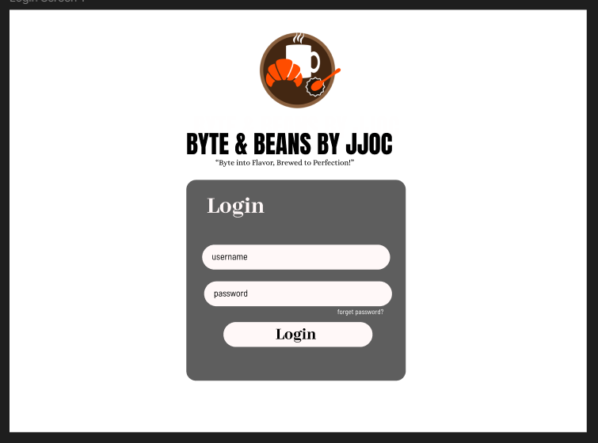 Redirects users to the **Admin Dashboard** or **Cashier Dashboard** based on their role.

The admin dashboard provides a central interface for managing the coffee shop’s operations. It features navigation options for Employee Management, Stock/Inventory Management, and Sales Reports.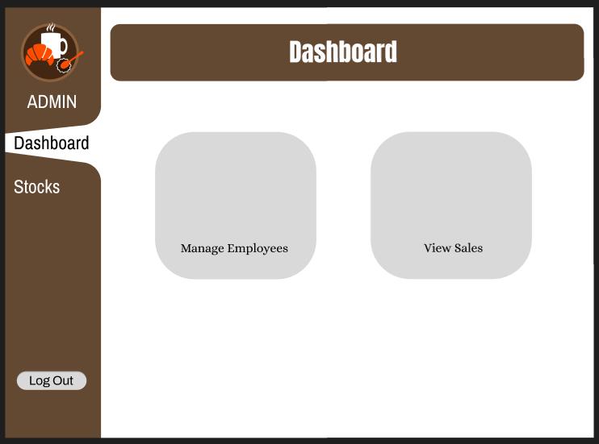

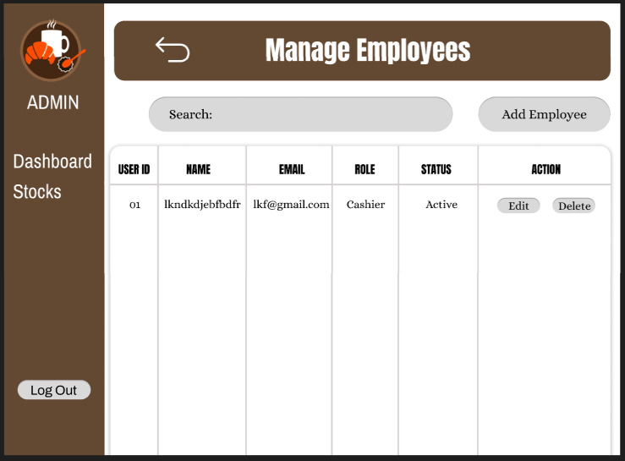

This screen allows the admin to manage employee records, ensuring up-to-date personnel data. A table displays employee details, including Employee ID, Name, Role, Email, and Status.

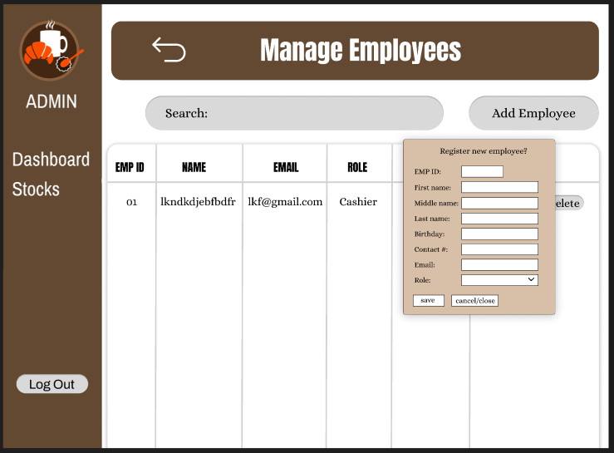

As the user click the add employee,  
The **Add Employee** allows administrators to register new employees in the system. It consists of a structured form that collects necessary employee details, ensuring accurate record-keeping.

After clicking the **Save** button on the "Add Employee" form, a confirmation popup appears to notify the admin that the employee has been successfully added to the system.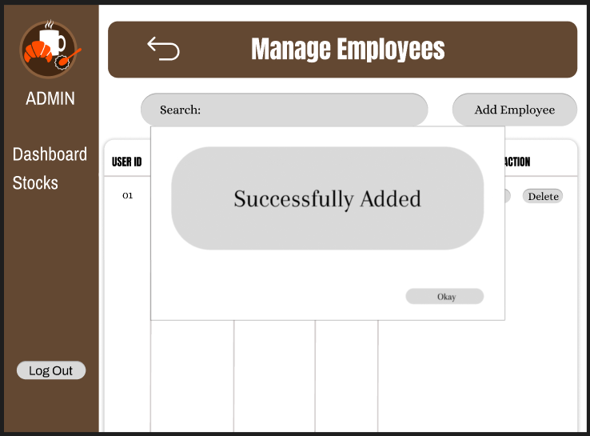

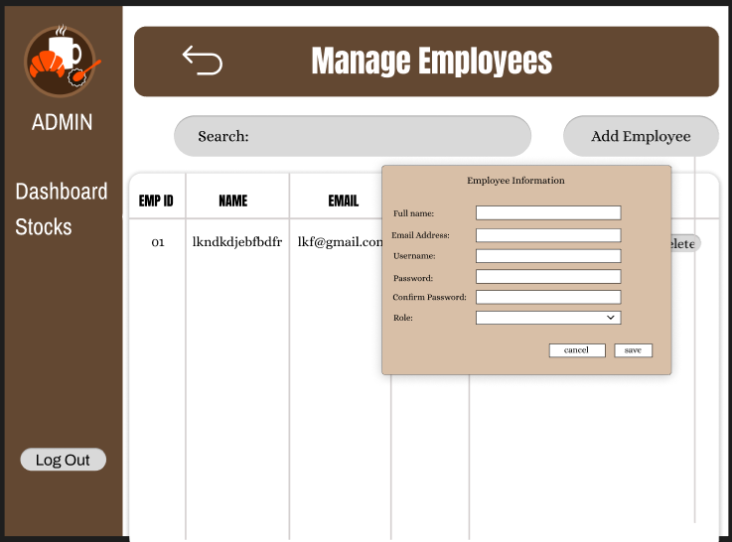

If the user click the edit,  
It updates Employee Information allows the admin to modify employee details, including name, email, username, password, and role. It features a dropdown for role selection and buttons to save changes or Cancel to discard them.

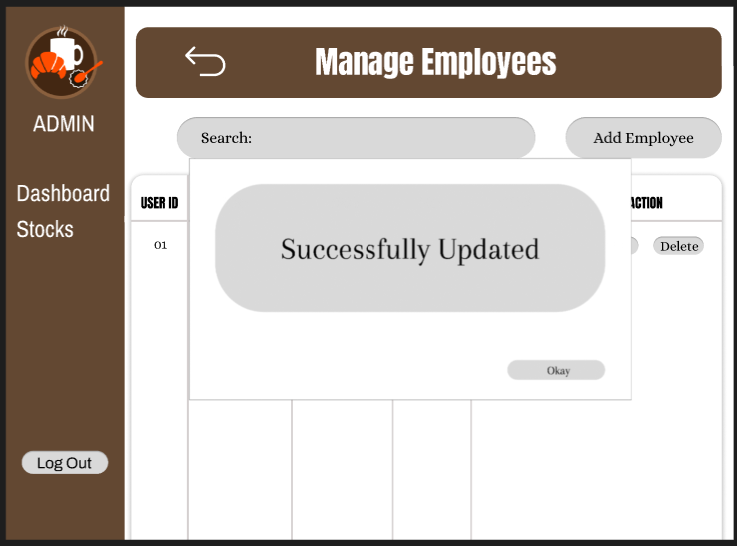

The Update Confirmation screen confirms that employee details have been successfully updated. It displays a success message with an "Okay" button to close the prompt and return to the management screen.

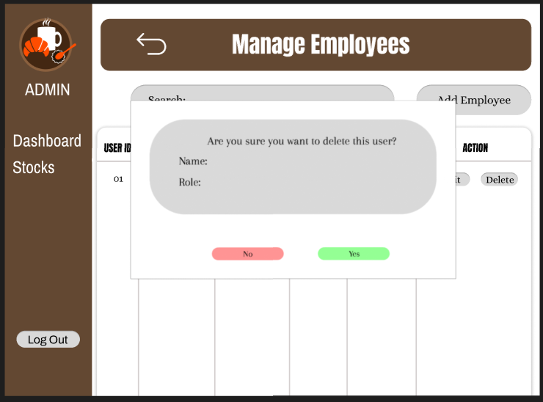

The Delete Confirmation screen prompts the user to confirm the deletion of an employee. It displays the user's name and role with "Yes" and "No" buttons to proceed or cancel the action.

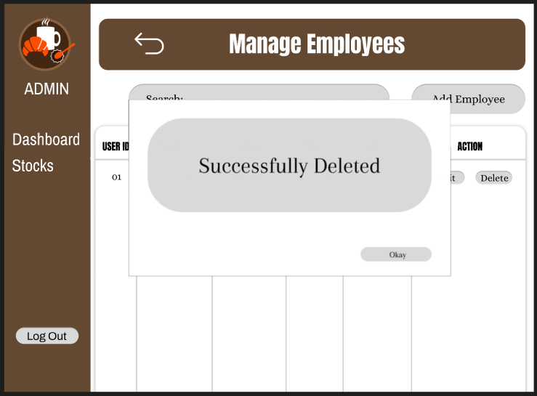

The Success Message confirms that the employee has been successfully deleted, with an "Okay" button to close the notification.

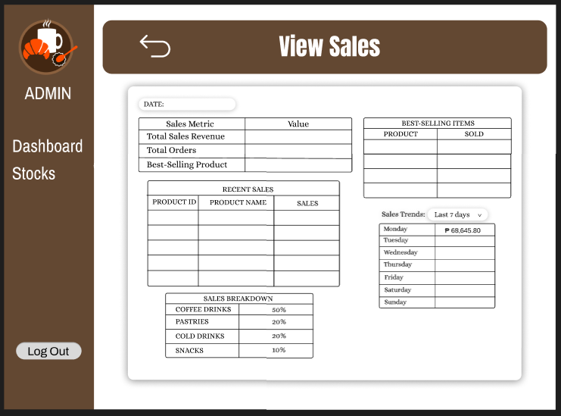   
The View Sales screen summarizes sales performance with key metrics, recent sales, best-selling items, and a sales breakdown. It also tracks sales trends over the past week, helping admins monitor revenue efficiently.

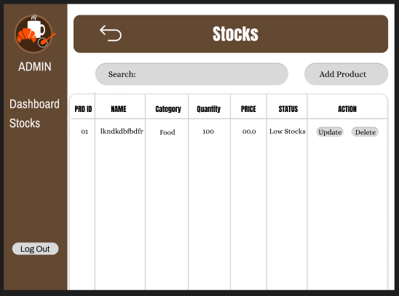

The Stocks screen allows admins to manage product inventory by adding, updating, or deleting items. It displays product details, stock levels, and status, ensuring efficient stock monitoring.

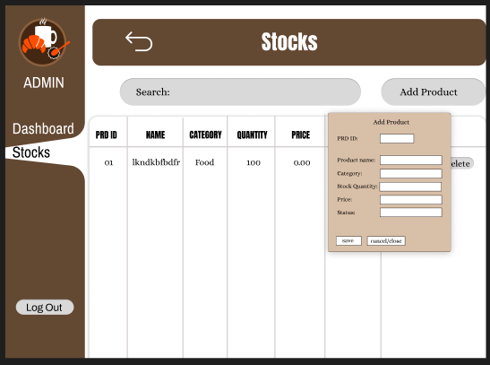

The Stocks screen now includes a pop-up form for adding new products. Admins can input product details such as ID, name, category, quantity, price, and status, ensuring easy inventory updates.

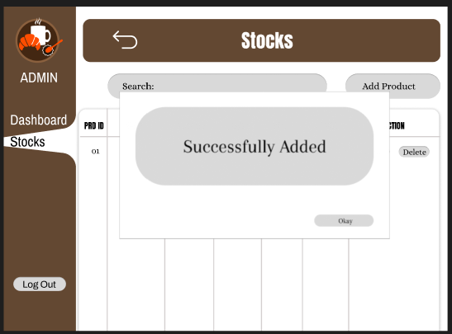

A confirmation message appears after successfully adding a product to the stock, ensuring the admin knows the update was completed.

Delete Product Confirmation dialog box asks for confirmation before proceeding, providing "Yes" and "No" buttons for user selection.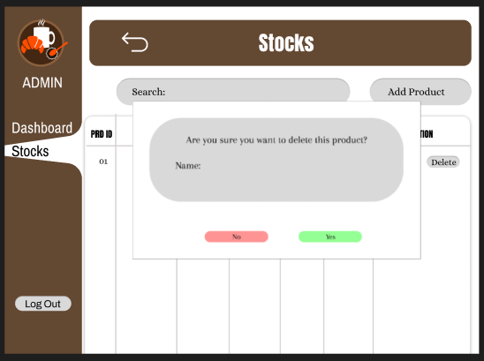

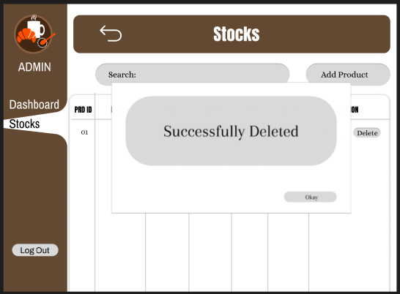

If the deletion is confirmed, a **Successful Deletion Confirmation** pop-up appears, informing the user that the product has been removed from the inventory.

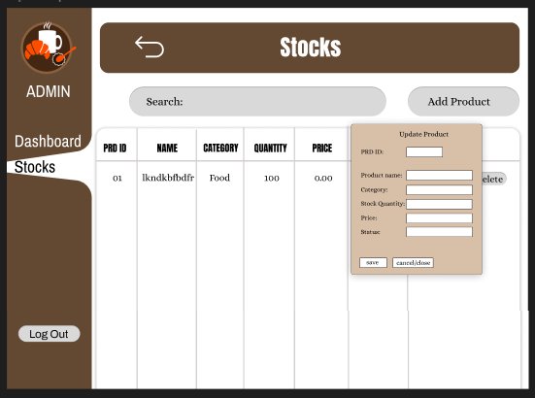

If the user click the edit it updates the product that allows users to modify product details like ID, name, category, quantity, price, and status. Users can save changes or cancel the update, ensuring accurate inventory management.

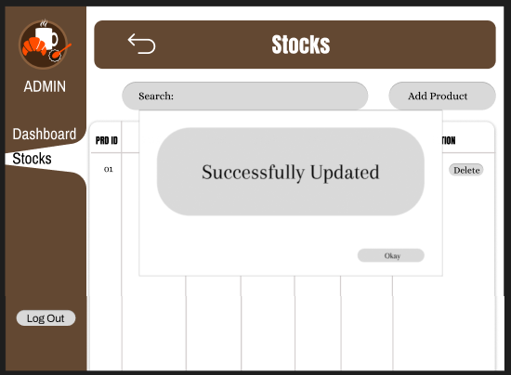

After clicking the save button it notifies users that product details have been successfully updated. It ensures users are aware of the changes made and confirms the update process is complete.

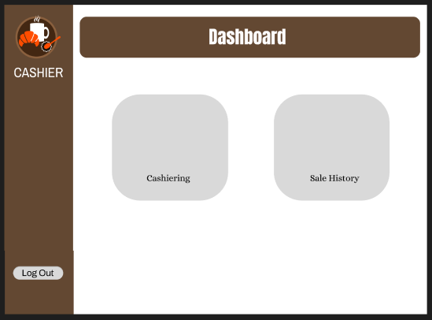

The Cashier Dashboard provides access to essential cashier functions. It features two main options: "Cashiering" for processing transactions and "Sale History" for viewing past sales. The interface is simple, ensuring efficiency in managing sales operations.

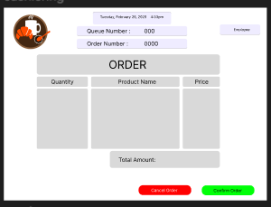

The Cashiering Screen allows the cashier to manage orders efficiently. It displays the queue and order numbers, a table for listing purchased products, and a total amount section. Buttons for cancelling or confirming orders streamline the transaction process.

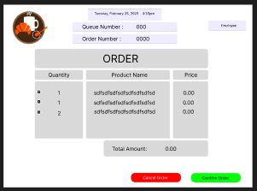

The Order Summary Screen displays the details of a customer's order, including product names, quantities, and prices. The total amount updates dynamically. The cashier can add products by typing their names and can remove items by clicking the "X" icon next to them. Additionally, the cashier can either cancel or confirm the order using the respective buttons.

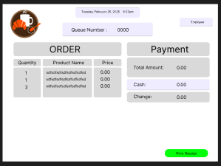

The Payment Screen displays the order summary alongside payment details. The cashier enters the cash amount, and the system calculates the change automatically. Once payment is completed, the cashier can print a receipt using the designated button.

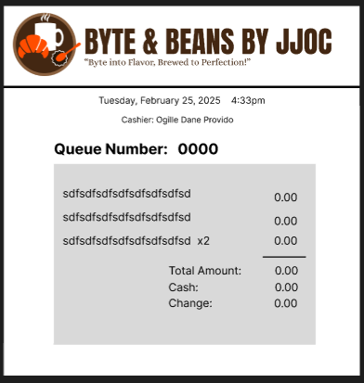

After confirming the order, it prints the receipt with the queue number, allowing customers to track their turn. The receipt includes the date and time, the cashier’s name, and a detailed list of ordered products with their quantities and prices. The queue number is prominently displayed at the top, ensuring customers know their position in line. At the bottom, the total amount, cash received, and change are shown for transaction verification. This structured format enhances efficiency in both order processing and customer service.

The system includes a **Sales History** button in cashier dashboard , allowing the cashier to review past transactions. This section presents a visual summary of sales trends through charts and a detailed table listing the products sold, their quantities, and the total sales amount. This feature helps in tracking sales performance and managing inventory effectively.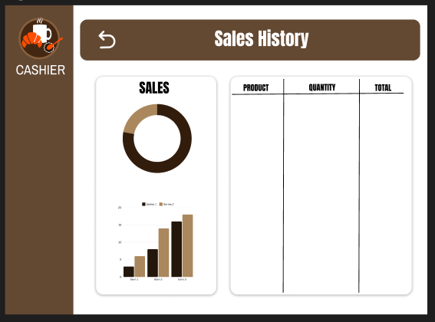

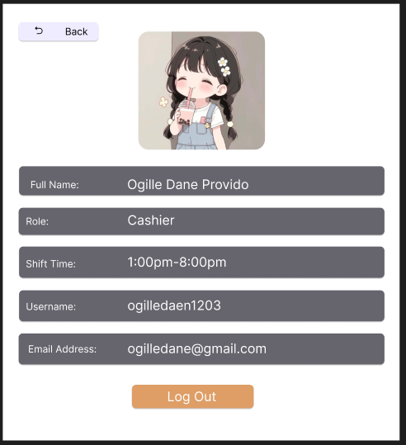 The Employee Section displays essential details about employees, including their Full Name, Role, Shift Time, Username, and Email Address. This section allows authorized users to manage employee records efficiently. Additionally, the Log out Button is included in this section, allowing employees to securely exit the system, ensuring data privacy and preventing unauthorized access.